FIELD SPRAYER QUALITY

ASSURANCE PROCEDURE

Attachments: Field Sprayer Cart/Hitch Q.A. Checklist
Pretreatment/Cure Testing Diagram
Mil Testing Diagram

Hatch & MEK Testing Diagram

References: PLS 802 Pretreatment Quality Assurance Procedure
PLS 205 Powder Paint Cure Quality Assurance Procedure

This procedure explains and outlines the quality assurance checks for the Field Sprayer cart and hitch.

RESPONSIBILITIES ARE AS FOLLOWS:

A) The Pretreatment Operator is responsible to:

- Record on the cart/hitch Q.A. checklist
- Name, Date and Time
- Pretreatment conditions (within 1.5 hours of the cart/hitch being pretreated in the wash)
- Water Break Test result
- Take the checklist to the painters as soon as possible

B) The Painters are responsible to:

- Receive the cart/hitch Q.A. checklist from the pretreatment operator

- Perform and document the following testing (all locations of testing must be documented on attached diagram)
- White Rag Test
- Phosphate Test using Test Solution #47
- Flash Rust N/C
- Chemical Run N/C

Note: a) and b) are to be done on the first cart/hitch of each shift while c) and d) are to be checked on all parts on the line randomly throughout the day.

- Document the following:
- Painted by (indicate both east and west side painter employee numbers)
- Cure conditions (oven temp., track speed and any non-conformances)
- Initiate and document the cart/hitch ID #s

- Place the magnetic temperature gauge on the hottest part of the cart. When the temp. on the gauge reads 100ºF or less, then you may start to take mil readings. Any mil readings taken above this temp. may result in damage to the probe.
- Perform and document the following inspections/testing:
- Pinhole Classification (visual inspection based on Powder Paint Cure Quality Assurance Specification)
- Gloss Rating (visual inspection based on Powder Paint Cure Quality Assurance Specification)
- Mil Thickness (document mils on appropriate diagram with min., max. and avg. on checklist / Cart – min. 42 readings / Hitch – min. 18 readings / use (Company) standards and specifications for paint coatings [sspc 597 doc] in reference to minimum mil thickness.)

Note: Ensure gauge is calibrated properly using an 11 gauge panel that has been blasted and washed within 5 days.

- Hatch Test Results (locations as per diagram and performed as per Powder Paint Cure Quality Assurance Specification)
- MEK Test Results (locations as per diagram and performed as per Powder Paint Cure Quality Assurance Specification)
- Paint Non Conformance (note any contamination, etc.)

Note: The above locations and testing are the minimum requirements. If it is suspected that a cart/hitch might not be cured, further testing should be done in the area of suspicion. All testing must be documented.

- Document for repaint:
- Circle ‘yes’ or ‘no’
- If ‘yes’, document reason for repaint, complete appropriate repairs as per repaint standards and document in Repaint Record section on checklist (mark area repainted by using numbered selection from mil testing location diagram / following the diagram(s), ‘T’ designates top, ‘B’ is bottom, ‘O’ is outside and ‘I’ is inside of tubes. – Example: If there was a light spot on the outside of area #6 you would record it as ‘6 – 0’).

- Inspected by sign it (painter/inspector).

- Touch up Hatch & MEK test marks with 5:1 urethane paint that has been catalyzed.

- The cart/hitch must be signed off as good and passing all inspections/testing by the (Company) Supervisor or designate.

- Sticker the cart & hitch with ID #s and put checklist with the cart & hitch for release to assembly.

Field Sprayer Cart/Hitch Quality Assurance Checklist
Date: __________________________ Time: _______________am / pm

Sequence Number: _______________ Cart / Hitch

PRETREATMENT

Wash Operator: __________________ Employee ID#: ______________

PREATREATMENT CONDITIONS

Inproclean 1300 H2O Rinse Cryscoat 347C H2O Rinse Ultra seal

%: ______ %: ______ %: ______ %: _______ %: _______
pH: ______ pH: ______ pH: ______ pH: _______ pH: _______ temp: ______ C temp: ______C temp: ______C temp: _______C temp: _______C
psi: ______ psi: ______ psi: ______ psi: _______ psi: _______
tds: _______ tds: _______ tds: _______

PRETREATMENT TESTING

Water break (visual): _________ Comments: ________________________________________
Phosphate (T.S. #47): _________ Comments: ________________________________________
White rag test : _________ Comments: ________________________________________
Flash rust N/C : ____________________________________________________________
Chemical run N/C: ____________________________________________________________

(All testing locations to be documented on appropriate diagram.)

PAINT

Painted by: (east) _____________________ Employee ID#: ________________

Painted by: (west)_____________________ Employee ID#: ________________

CURE CONDITIONS
Oven Temp: ______________ Track Speed: ____________ft/min.

Comments: ____________________________________________________________________

CURE TESTING

Pinholes Classification: ___________ Paint Mils:

Hatch Test Result: ___________ Minimum: ______________

MEK Test Result: ___________ Maximum: ______________

Gloss Rating: ___________ Average: ______________

Paint non-conformance: __________________________________________________________

____________________________________________________________________________

Repaint: NO
YES Reason: _____________________________________________________

Inspection by: ___________________________ Employee ID#:_____________________

Signed off by: ___________________________

REPAINT RECORD

Area(s) repainted: _______________________________________________________________

Reason: _______________________________________________________________________

Description of work: ____________________________________________________________

Rechecked/ signed off by: ________________________ Employee ID#: __________________

Time/Date Started: ________________________
Time/Date Finished: ________________________

Total Time to Fix: ________________________
SPRAYER CART/HITCH HATCH & MEK LOCATIONS

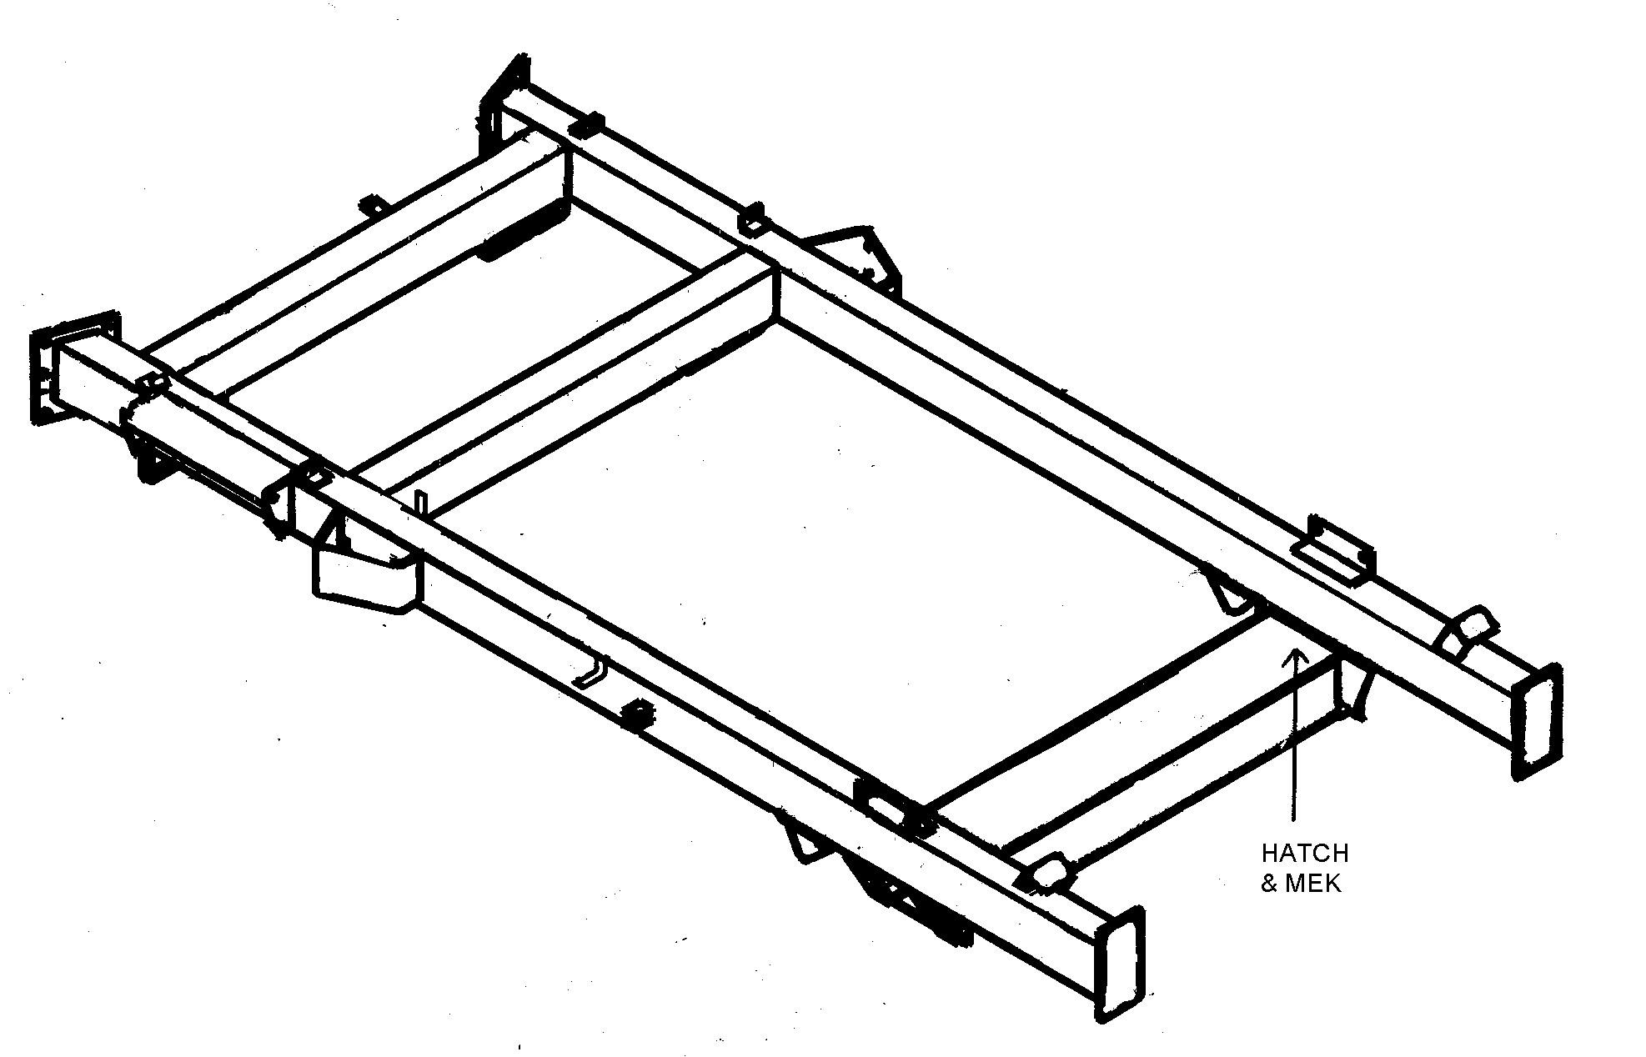

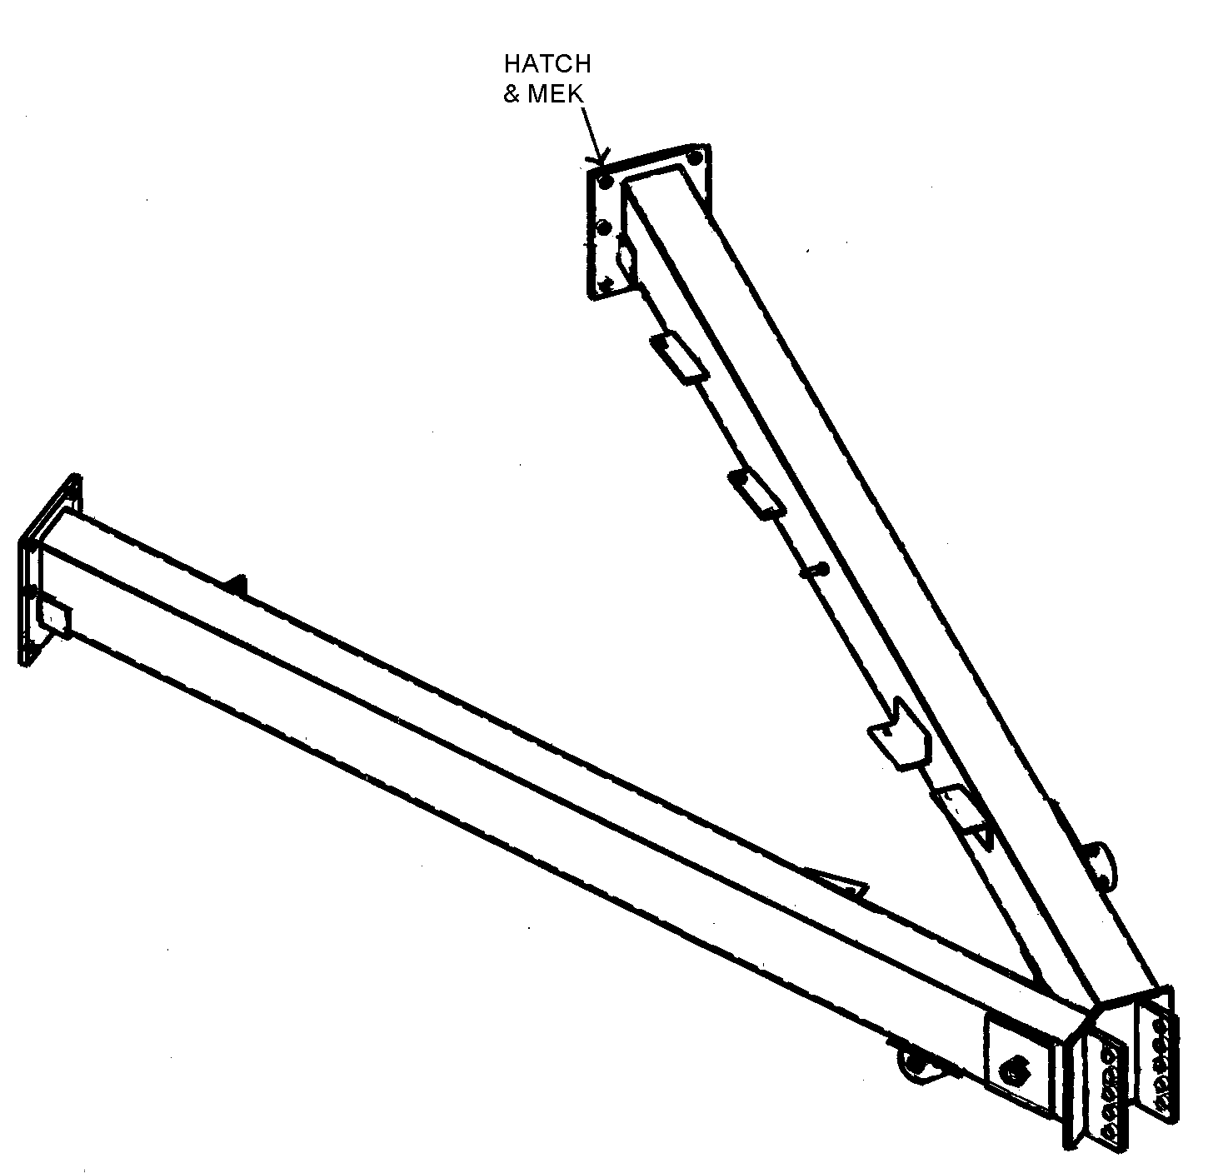

SPRAYER CART/HITCH MIL TESTING LOCATIONS
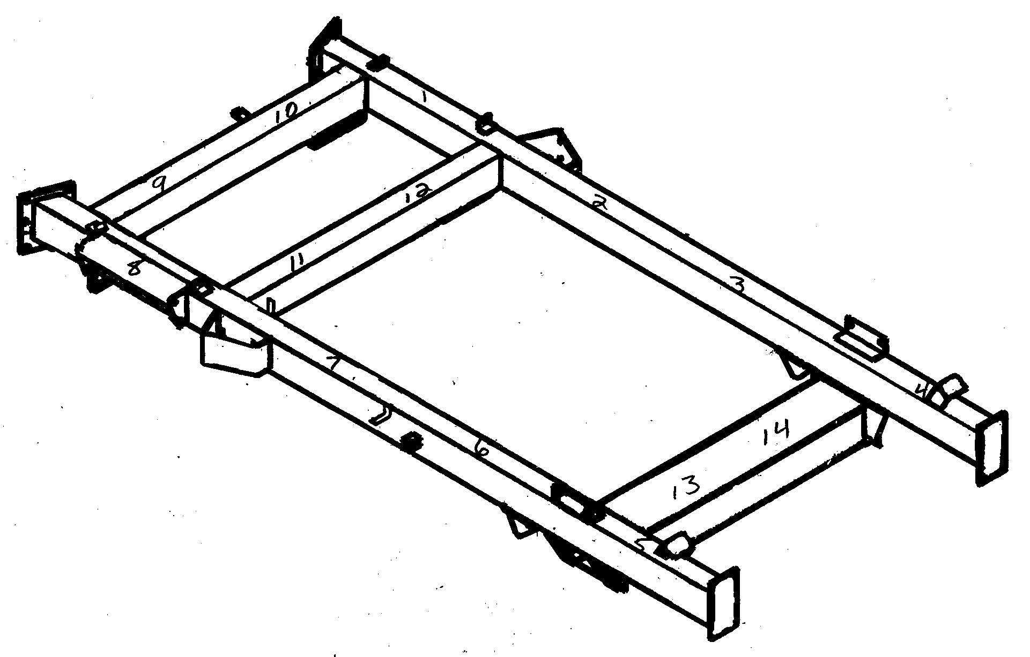

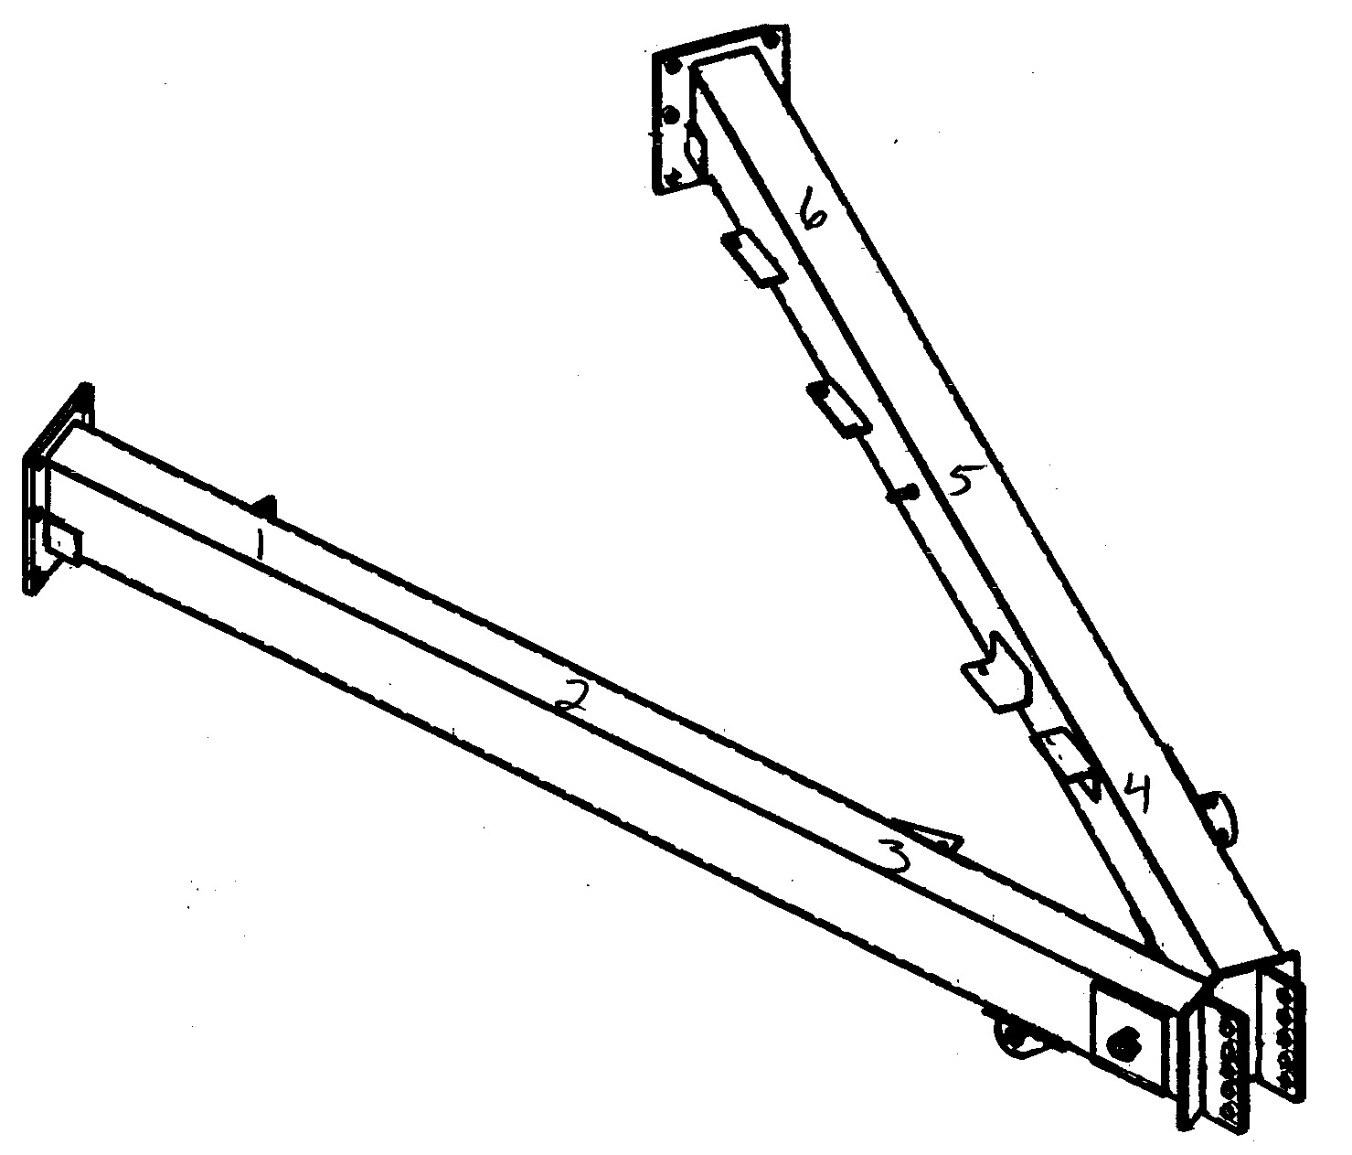
SPRAYER CART/HITCH PRETREATMENT TEST LOCATIONS

W - White Rag Test
F - Flash Rust
C - Chemical Run
P - Phosphate Test
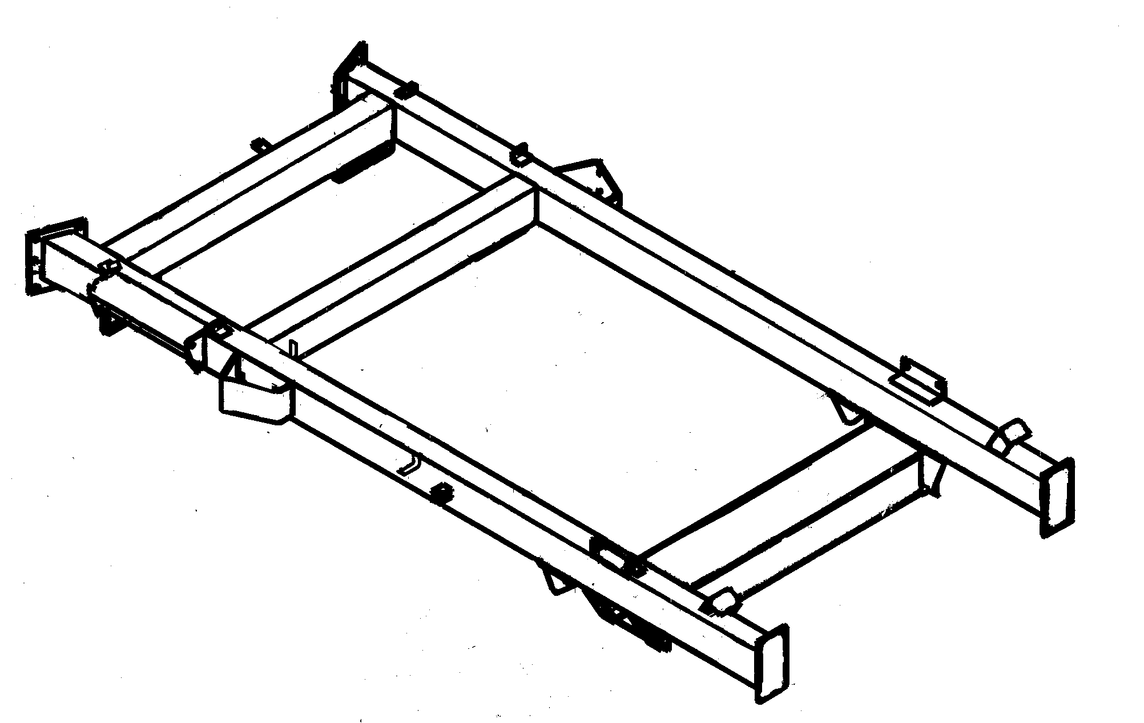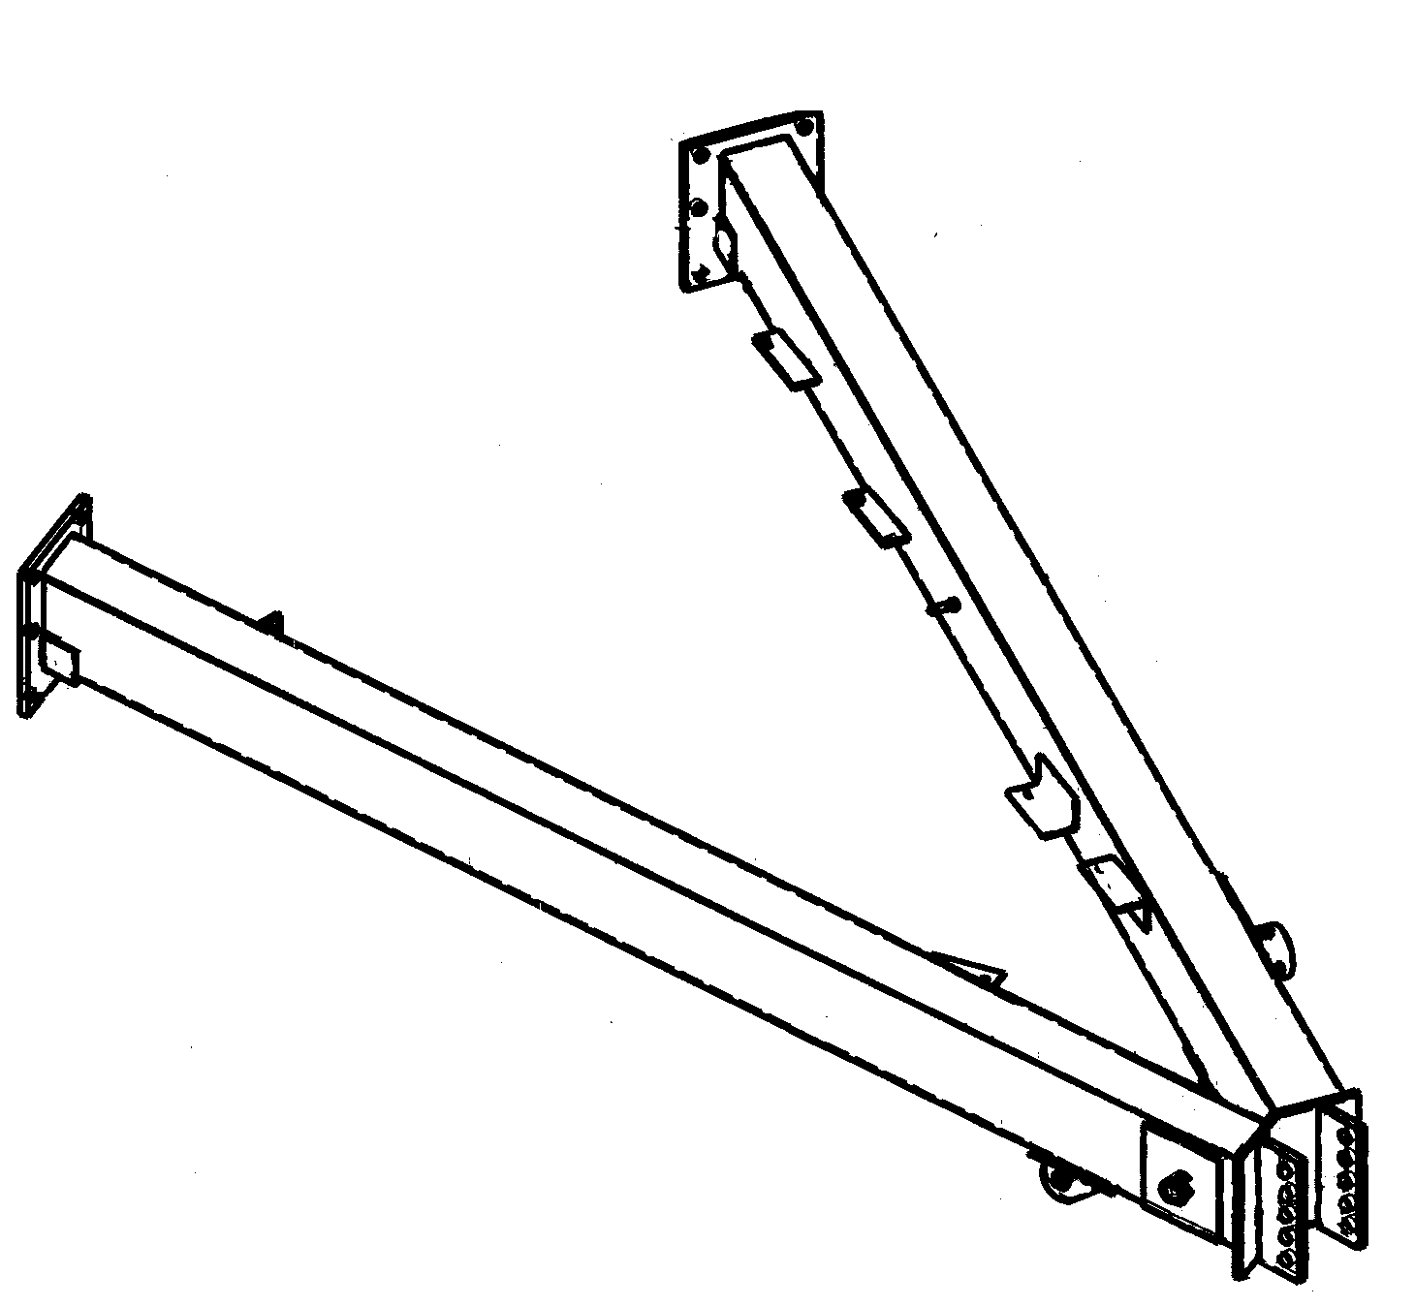

SPRAYER CART/HITCH MIL TESTS

Cart:
Low: _____
High: _____
Avg.: _____
Hitch:
Low: _____
High: _____
Avg.: _____

